Waymo Car Follow Data Sample (Example: scenario id 505)

You can find process code here: Add Link here (not finished)

**Attribute Of Car Follow Data**

You can find sample dataset here: CarFollowData/sid505_sample.csv

**scenario**_id: A unique string identifier for this scenario.

**scenario_id_num**: A unique number identifier for this scenario.

* we pull scenarios with potentially good CF pairs (e.g., no turning, AV is likely constrained).

**time**: Repeated field containing timestamps for each step in the Scenario starting at zero.

**object_id:** A unique numeric ID for each object.

**object_type**: The type of object for this track (vehicle, pedestrian, or cyclist).

**is_sdc**: The track index of the autonomous vehicle in the scene.

* 1 -> autonomous vehicle, otherwise 0.

**Speed**: Speed of subject vehicle

* Provided by waymo, calculated using $√{(velocity_x}^{2}+{velocity_y}^{2}$)

**LeaderSpeed**: Speed of Leader of Subject vehicle

* Provided by waymo, calculated using $√{(velocity_x}^{2}+{velocity_y}^{2}$)

**speedDiff**: difference between speed of subject and leader

**spacing**: spacing between subject vehicle and leader of subject vehicle

* Spacing calculation is by mapping the position of vehicle in the lane center and then we calculate the distance between the two points along the lane center.  (E.g., if the road is curvy, what we calculate is NOT the Euclidian distance, but the distance along the arc.)

**lane_deviation**: Lane deviation of subject vehicle

* Calculated by the shortest distance between the nearest point of lane center and point of subject trajectory.

**Leader_lane_deviation**: Lane deviation of leader of subject vehicle

* Calculated by the shortest distance between the nearest point of lane center and point of leader of subject trajectory.

**acceleration**: acceleration of subject vehicle (calculated by taking the derivative of speed)

**Dis_TO_av**: Subject Vehicle position (from ref point) – AV position.

* Negative for upstream vehicles and positive for downstream vehicles.

**Leader_Dis_TO_av**: Leader of subject Vehicle position (from ref point) – AV position.

* Negative for upstream vehicles and positive for downstream vehicles.

**laneID**: A unique number identifier for each lane.

* AV lane: 0
* left lane or up lane: -1 (based on the movement of vehicle)
* right lane or down lane: 1 (based on the movement of vehicle)

**position_num**: 0- AV; 100->AV leader; -100->AV follower; On AV lane, vehicle numbering from upstream to downstream: -3, -2, -1, -100 (follower), 0 (AV), 100 (leader), 1, 2, 3.

Note: in the output, it’s organized in the way of subject vehicle.  Thus, if AV’s leader doesn’t have an active leader, the record of the AV leader is NOT included in the data.

**Visualization Of Car Follow Data**

Left side graph: Distance to Reference Point

* It contained AV and Vehicles we selected in AV Lane
* Start point of av is the reference point for each vehicle

Right side graph: Map for this scenario

* This graph only containes Lane Center for Map, AV Lane and AV trajectory.

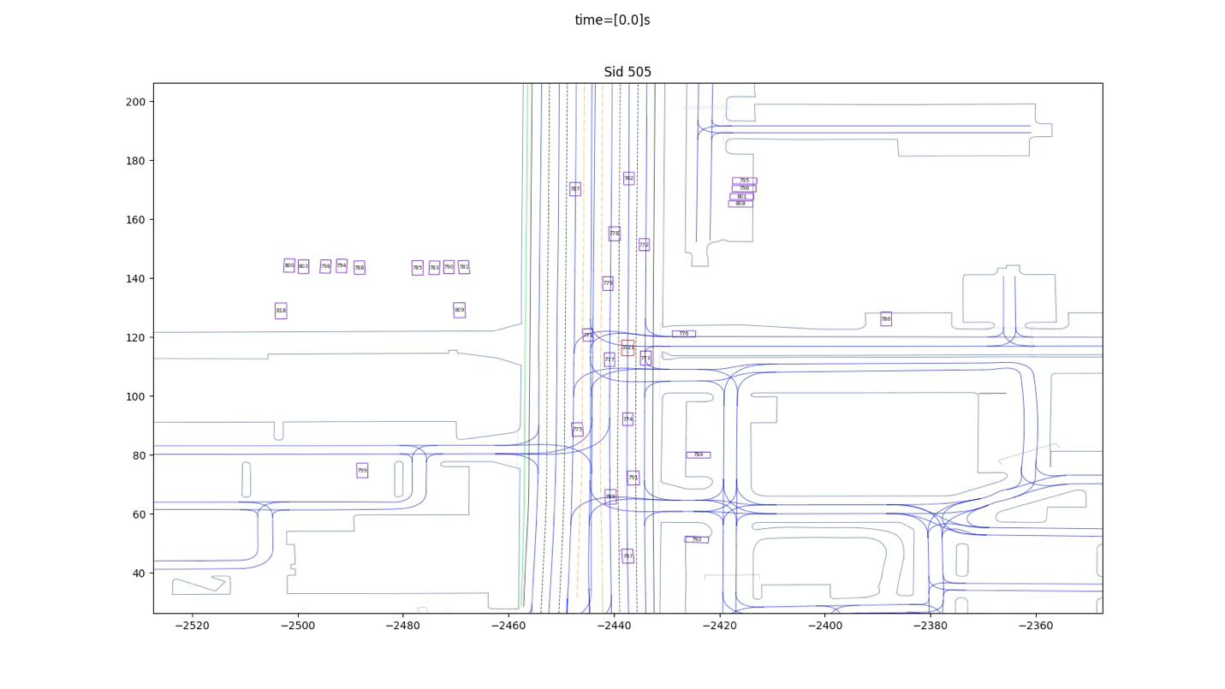**Animation for this scenario**

Animation

* Red box is autonomous vehicle.